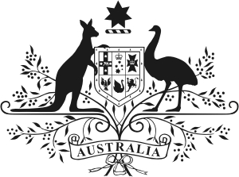
Australian Government
Australian Embassy Moscow

CURRICULUM VITAE (CV) PROFORMA

Please ensure all fields are fully completed in English and include all periods of employment and unemployment. If you require extra space, please use a second copy of this page.

SURNAME, Name, Patronymic: _PETROV PETR_______________

Date of Birth (DD/MM/YY): __19.02.1959___

Employment History (including all periods of unemployment)

Dates (MM/YY to MM/YY) | Employer (full name, address and country) | Position/ Duties description
01/1977-01/1994 | RIALBAZA №1,№2, RUSSIA, MOSCOW,KREML,17 | MASTER
02/1994-02/2009 | ACCOUNTING SYSTEM  RUSSIA,MOSCOW | SELLER CONSULTANT
03/2009-07/2012 | INDIVIDUAL INTREPNEUR RAGIMOV, MOSCOW,RYZDOLSKAIA,42/2 | SELLER
08/2012- through the present time | VINOKUROV & KUZNETSOV MOSCOW,KR.PRESNYA,9 | STOREKEEPER

Education History (since completing school)
Dates (MM/YY to MM/YY) | Institution (full name and country) | Qualifications Obtained
09/1980-06/1983 | FOOD COLLEGE | MOSCOW REGION, LYUBERTSY

